Word Template for Journal of Basrah Researches (Sciences)

First A. Author¹, Second B. Author^{2,*}

¹ First A. Authors’ affiliation and address. [ORCID]
² Second B. Author’s affiliation and address. [ORCID]

ARTICLE INFO | ABSTRACT
Received Date Month Year Accepted Date Month Year  Published Date Month Year | The abstract is a shortened version of the paper and should contain all information necessary for the reader to determine: (1) what the objectives of the study were; (2) how the study was done; (3) what results were obtained; (4) the significance of the results. The typical length of an abstract is 150 – 200 words.
  - Keywords:
Keyword1, keyword2, keyword3, etc.
Citation: First A. Author et al., J. Basrah Res. (Sci.) xx(x), xx (xxxx). DOI:https://doi.org/10.56714/bjrs.xx.x.x
- Introduction
We request authors to follow this guideline and format their manuscripts exactly the same as this document.[1] The easiest way to do this is download this template and replace its contents with those in your manuscript[2].
- Page Dimensions
All material on all pages should fit within an area of A4 (21 x 29.7 cm), 2.8 cm from the top of the page and ending with 2.4 cm from the bottom. The left and right margins should both be 2.4 cm.
- Main Text
This section provides details for typesetting your manuscript according to the formatting guidelines set for JOBRS Journal. Use 11-point Times New Roman regular font for typesetting of the main text in the document.
The main text starts at the top of the page and continues in a one-column format. Place an indentation for each paragraph starting from the first in all sections or subsections. There is no space between paragraphs within the text. Add an 11-point space after the text in each section or subsection.

Selecting a Template (Heading 2)
First, confirm that you have the correct template for your paper size. This template has been tailored for output on the A4 paper size.

Units
- Use either SI (MKS) or CGS as primary units. (SI units are encouraged.) English units may be used as secondary units (in parentheses). An exception would be the use of English units as identifiers in trade, such as “3.5-inch disk drive”.
- Do not mix complete spellings and abbreviations of units: “Wb/m2” or “webers per square meter”, not “webers/m2”. Spell out units when they appear in text: “. . . a few henries”, not “. . . a few H”.
  - Default Fonts
Use only Times New Roman fonts throughout the document. If any special font is required to display the text properly, please mention this during the manuscript submission process.
  - Typeset Text
Use 20-point-bold Times New Roman font for the paper title. Author’s names (12-point Times New Roman bold) and affiliations (11-point Times New Roman regular) are aligned left. Separate addresses for different affiliations and add a space between authors’ names and affiliations.
  - Page Numbering / Header and Footer
Do not include headers, footers, or page numbers other than those already set in this manuscript. Note that the headers, footers or page numbers are different for the first page and the rest of the pages. Actual page numbers and other running heads will be modified when publications are assembled.
  - Mathematics
Math typesetting can be done by Equation Editor, or by any other system that produce clear math types (Times New Roman regular 11 pt.). Symbols and shorter expression can be placed within the text, e.g. ε→0. More complex expression should be placed in a center of a new line:
(1)
All equations should be numbered, right justified. They should be referred just like figures and tables, e.g. Eq. (1). Unless it is absolutely necessary, equation numbers should not have part to them, e.g. instead of using Eq. 1(a) and Eq. 1(b). Number them as Eq. (1) and Eq. (2).
- Figures/Captions
Place tables/figures/images on the top of each column (see Table 1 and Fig. 1). Each figure or table must include a caption set in 11-point Times New Roman regular font, placed below the figure or table. The caption is left justified.
It is highly recommended that figures/images/graphs/diagrams that might have been created in other software, e.g. Excel, AutoCAD, etc., or even the ones that are composed by various graphical components (textbox, arrows, shapes, etcs.) of MS Words itself be grouped and converted to PNG (highly preferred) or an appropriate raster image format before including them in final manuscript in order to stop the linking of figures back to its sources or to avoid the graphical components scattering over the pages. The “Paste Options” in MS Word can be useful for a quick conversion. Use Drawing Canvas when necessary.
Reference to the figure should follow the format “Fig. 1”. Use “Figure 1” instead if it is at the beginning of a sentence. Figure numbering and referencing should be done sequentially, e.g. Fig. 1, Fig. 2, Table 1, Table 2., etc. Use Fig. 1(a), Fig. 1(b), etc. for figures with multiple parts.
Table 1. Font type and size list for JOBRS’s template.

Item | Font | Font Type | Font Size
Title | Times New Roman | Bold | 20
Author names | Times New Roman | Bold | 12
Author affiliation/email | Times New Roman | Regular | 11
Abstract/Keywords | Times New Roman | Regular | 11
Level 1 headings | Times New Roman | Bold | 12
Level 2 headings | Times New Roman | Bold | 11
Level 3 headings | Times New Roman | Regular | 11
Figure/table captions | Times New Roman | Regular | 11
Main text/References | Times New Roman | Regular | 11

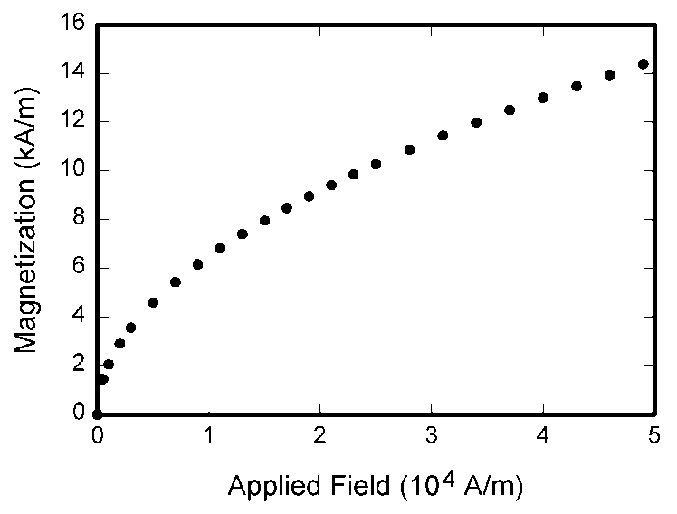
Fig. 1. The figure is center-aligned and the caption of the figure is left-aligned.
- Sections
The heading of sections should be in 12-point Times New Roman bold font and flush left. Sections and subsequent sub-sections should be numbered and flush left in the same manner. Sections numbers are in Roman style.
  - Subsection Level 1
Use 11-point Times New Roman bold font for the heading of subsections.
    - Sub-subsection Level 2
Use 11-point Times New Roman regular font for the heading of subsubsections.
    - Sub-subsection Level 2
      - Sub-subsection Level 3
- Conclusion
Provide a statement that what is expected, as stated in the "INTRODUCTION" section can ultimately result in "RESULTS AND DISCUSSION" section, so there is compatibility. Moreover, it can also be added the prospect of the development of research results and application prospects of further studies into the next (based on result and discussion).

Acknowledgement
Funding supports should be acknowledged in this section.
Appendix A: An example appendix
Authors including an appendix section should do so before References section. Multiple appendices should all have headings in the style used above. They will automatically be ordered A, B, C etc.
A.1. Example of a sub-heading within an appendix
There is also the option to include a subheading within the Appendix if you wish.
References
References should be arranged by the order in which they appear in the text. Only the references that are cited in the text should be added to the reference list. There are standard reference formats for most types of document. Below are examples of the most common types of document you might want to reference. Each of the following gives a suggested standard format for the reference followed by examples for the different document types.
Notes : Use a DOI for each reference. Put the DOI at the end of your reference.
Book
[Ref number] Author’s initials. Author’s Surname, Book Title, edition (if not first). Place of publication: Publisher, Year.
[1] I.A. Glover and P.M. Grant, Digital Communications, 3rd ed. Harlow: Prentice Hall, 2009.
Book chapter
[Ref number] Author’s initials. Author’s Surname, “Title of chapter in book,” in Book Title, edition (if not first), Editor’s initials. Editor’s Surname, Ed. Place of publication: Publisher, Year, page numbers.
[2] C. W. Li and G. J. Wang, "MEMS manufacturing techniques for tissue scaffolding devices," in Mems for Biomedical
Applications, S. Bhansali and A. Vasudev, Eds. Cambridge: Woodhead, 2012, pp. 192-217.
Electronic Book
[Ref number] Author’s initials. Author’s Surname. (Year, Month Day). Book Title (edition) [Type of medium]. Available: URL
[3] W. Zeng, H. Yu, C. Lin. (2013, Dec 19). Multimedia Security Technologies for Digital Rights Management [Online].
Available: http://goo.gl/xQ6doi
Journal article
[Ref number] Author’s initials. Author’s Surname, “Title of article,” Title of journal abbreviated in Italics, vol. number, issue number, page numbers, Abbreviated Month Year.
[4] F. Yan, Y. Gu, Y. Wang, C. M. Wang, X. Y. Hu, H. X. Peng, et al., "Study on the interaction mechanism between laser and
rock during perforation," Optics and Laser Technology, vol. 54, pp. 303-308, Dec 2013.
E-Journal article
[Ref number] Author’s initials. Author’s Surname. (Year, Month). “Title of article.” Journal Title [type of medium]. volume number, issue number, page numbers if given. Available: URL
[5] M. Semilof. (1996, July). “Driving commerce to the web-corporate intranets and the internet: lines blur”. Communication Week [Online]. vol. 6, issue 19. Available: http://www.techweb.com/se/directlinkcgi?CWK19960715S0005
Conference papers
[Ref number] Author’s initials. Author’s Surname, “Title of paper,” in Name of Conference, Location, Year, pp. xxx.
[6] S. Adachi, T. Horio, T. Suzuki. "Intense vacuum-ultraviolet single-order harmonic pulse by a deep-ultraviolet driving laser," in Conf. Lasers and Electro-Optics, San Jose, CA, 2012, pp.2118-2120.
Reports
[Ref number] Author’s initials. Author’s Surname, “Title of report,” Abbreviated Name of Company., City of Company., State, Report number, year.
[7] P. Diament and W. L. Luptakin, “V-line surface-wave radiation and scanning,” Dept. Elect. Eng., Colombia Univ., New York, Sci Rep. 85, 1991.
Theses/Dissertations
[Ref number] Author’s initials. Author’s Surname, “Title of thesis,” Designation type, Abbrev. Dept., Abbrev. Univ., City of Univ., State, Year.
[8] J. O. Williams, “Narrow-band analyser,” Ph.D. dissertation, Dept. Elect. Eng., Harvard Univ., Cambridge, MA, 1993.
Patents
[Ref number] Author’s initials. Author’s Surname, “Title of patent,” Country where patent is registered. Patent number, Abbrev of Month Day Year.
[9] J. P. Wilkinson, “Nonlinear resonant circuit devices,” U.S. Patent 3 624 125, July 16 1990.
Websites
[Ref number] Author’s initials. Authors Surname. (Year, Month. Day). Title of web page [Online]. Available: URL
[10] BBC News. (2013, Nov. 11). Microwave signals turned into electrical power [Online]. Available: http://www.bbc.co.uk/news/technology-24897584

نموذج الملخص باللغة العربية لمجلة ابحاث البصرة (العلميات)
المؤلف الأول¹ ، المؤلف الثاني ^{*2}
¹ انتماء المؤلف الاول وعنوانه.
² انتماء المؤلف الثاني وعنوانه..
الملخص | معلومات البحث
الملخص هو نسخة مختصرة من الورقة ويجب أن يحتوي على جميع المعلومات اللازمة للقارئ لتحديد: (1) ما هي أهداف الدراسة ؛ (2) كيف تمت الدراسة ؛ (3) ما هي النتائج التي تم الحصول عليها ؛ (4) أهمية النتائج. الطول النموذجي للملخص هو 150-200 كلمة. | الاستلام يوم شهر سنة  القبول يوم شهر سنة  النشر يوم شهر سنة
الكلمات المفتاحية
الكلمة الرئيسية 1 ، الكلمة الرئيسية 2 ، الكلمة الرئيسية 3 ، وما إلى ذلك.
 | Citation: First A. et al., J. Basrah Res. (Sci.) xx(x), xx (xxxx). DOI:https://doi.org/10.56714/bjrs.xx.x.x

